***«Diagnosis and Corneal Parameter Analysis in Children with Keratoconus: A Two-Year Continuous Study in Ukraine»***

**Purpose:** The purpose of this study was to assess the prevalence of keratoconus in children aged 6-16 years in Ukraine, analyze age-related corneal parameter changes, and identify potential risk factors for developing keratoconus.

**Methods***:* Study Design and Participants: This two-year longitudinal study was conducted at the National Children's Specialized Hospital "Ohmatdyt" in Kyiv, Ukraine. The study involved 420 children aged 6 to 16 years who underwent comprehensive corneal examinations using the Pentacam device. The Pentacam (Oculus GmbH, Wentzler, Germany) was used for corneal measurements. Data were processed using SPSS version 25.0. Corneal parameters, including thickness and curvature, were analyzed based on age groups. Participants were selected based on their attendance at routine ophthalmic check-ups. Quantitative and qualitative methods were employed to assess corneal health. This included measurements of corneal thickness, anterior and posterior curvature, and the identification of keratoconus signs.  Diagnostic Criteria:  Keratoconus was diagnosed based on clinical signs and corneal topography. The criteria included corneal thinning, increased curvature, and specific topographic patterns indicative of keratoconus. Inclusion criteria were children aged 6 to 10 years attending routine ophthalmic check-ups. Exclusion criteria included prior corneal surgeries and eye diseases other than keratoconus. Keratoconus was diagnosed based on corneal thinning (<500 μm) and increased curvature (>47 diopters).

Data were analyzed to determine the prevalence of keratoconus, focusing on age-related changes in corneal parameters. Statistical tests included t-tests for comparing means and chi-square tests for categorical data. A p-value of <0.05 was considered statistically significant. The study protocol was approved by the Ethics Committee of the National Children's Specialized Hospital "Ohmatdyt". Informed consent was obtained from the parents or legal guardians of all participants. [4]

**Results:**  The study included 420 children, who were divided into four groups based on age (6-10 years and 10-16 years) and the presence of keratoconus:

1. **Group 1 (6-10 years, without keratoconus)**:
   * Average corneal thickness: 532.875 µm
   * Average anterior corneal curvature: 7.49-7.86 mm
   * Average posterior corneal curvature: 6.12-6.53 mm
2. **Group 2 (10-16 years, without keratoconus)**:
   * Average corneal thickness: 566.375 µm
   * Average anterior corneal curvature: 7.49-7.89 mm
   * Average posterior corneal curvature: 6.13-6.48 mm
3. **Group 3 (6-10 years, with keratoconus)**:
   * Average corneal thickness: 512-588 µm
   * Average anterior corneal curvature: 7.33-7.84 mm
   * Average posterior corneal curvature: 5.83-6.68 mm
4. **Group 4 (10-16 years, with keratoconus)**:
   * Average corneal thickness: 489-584 µm
   * Average anterior corneal curvature: 5.91-6.96 mm
   * Average posterior corneal curvature: 4.84-5.31 mm

**General findings:**

* Keratoconus or a risk of developing it was diagnosed in 92 children (21.9%). The highest prevalence was observed in older children aged 10-16 years (Group 4), where 13% of the participants had keratoconus.
* **Corneal thinning** was statistically significant in children aged 10-16 years with keratoconus (Group 4), where the average corneal thickness was 489-584 µm, significantly lower than in healthy children of the same age group (Group 2, p < 0.05).
* **Corneal curvature** was also significantly increased in children with keratoconus in the 10-16 years age group, with the anterior curvature reaching up to 6.96 mm in children with keratoconus (Group 4), compared to 7.49-7.89 mm in healthy children (Group 2).
* In younger children (6-10 years), the difference between groups with and without keratoconus was less pronounced but still statistically significant (p < 0.05).

**Key conclusions:**

* **Children aged 10-16 years** with keratoconus had significantly lower average corneal thickness compared to younger children and healthy peers.
* Corneal thickness and curvature were most critical in older children with keratoconus, highlighting the importance of early diagnosis and monitoring, especially during puberty.

**Conclusion:** Early detection and monitoring of keratoconus are crucial for preventing progression, particularly in older children aged 10-16 years. Future research should focus on developing new morphometric indicators for improved risk assessment.

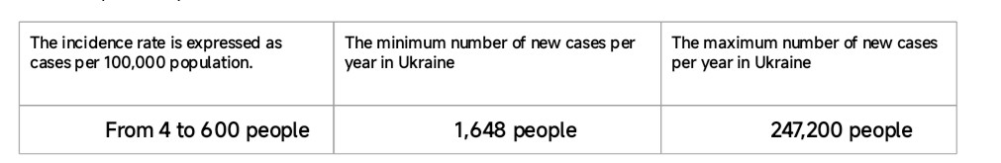***Introduction***: Keratoconus is a disease that affects the cornea of the eye, leading to its protrusion and thinning, significantly impacting vision. In Ukraine, as well as globally, this issue remains relevant, especially among the child population. The prevalence ranges from 0.01% to 0.4% (depending on the level of diagnosis and detection) [1] It affects 4 to 600 individuals per 100,000 population. [2] Among children with Down syndrome, the prevalence of keratoconus is 1.5%. [3] In 90% of cases, the condition is bilateral. 52% of patients with keratoconus suffer from various forms of atopy (asthma, eczema, general allergies). [4] Keratoconus is very rarely seen in patients with diabetes. In 66% of cases, patients with keratoconus have a prolonged history of continuous eye rubbing. Almost all countries observe a steady increase in the number of patients with keratoconus and Keraectasia. making this disease a socially significant problem. [5] According to WHO data (2011), the proportion of KC in ophthalmology accounts for up to a quarter of all eye diseases. [6]  As of the latest available data until April 2023, the population of Ukraine was estimated at approximately 41.2 million people. Considering the population of Ukraine and the incidence rate of keratoconus ranging from 4 to 600 cases per 100,000 population per year, it can be calculated that annually in Ukraine there could be approximately 1,648 to 247,200 new cases of keratoconus registered. (***Illustration 1)***

Based on the provided data and calculations, it can be estimated that in Ukraine annually registers from 1,648 to 247,200 new cases of keratoconus among the general population. This wide range indicates significant differences in levels of diagnosis, access to medical care, and other factors that may affect the registration of new cases of the disease. Additionally, we have calculated that among individuals with Down syndrome in Ukraine, from 25 to 9,270 new cases of keratoconus may be registered annually, considering the overall frequency of this condition and the specific vulnerability of this population group. These estimates are based on statistical data and assumptions and may vary depending on many factors, including. A bar chart with a linear scale is presented, displaying the estimated 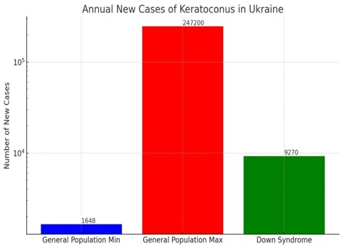annual number of new cases of keratoconus in Ukraine for the general population (minimum and maximum numbers) and among individuals with Down syndrome**. (Figure 2)**

**Objective**: The aim of this study is to assess the prevalence of keratoconus among children in Ukraine through a two-year study conducted at the National Children's Specialized Hospital "Ohmatdyt". The study also seeks to evaluate the demographic distribution and corneal parameter changes associated with keratoconus, and to identify any significant epidemiological patterns within the pediatric population. The purpose of this study is to evaluate the prevalence and epidemiological characteristics of keratoconus among children in Ukraine, using data collected over a two-year period at the National Children's Specialized Hospital "Ohmatdyt".

**Methods***:* Study Design and Participants: This two-year longitudinal study was conducted at the National Children's Specialized Hospital "Ohmatdyt" in Kyiv, Ukraine. The study involved 420 children aged 8 to 13 years who underwent comprehensive corneal examinations using the Pentacam device. The Pentacam (Oculus GmbH, Wetzlar, Germany) was used for corneal measurements. Data were processed using SPSS version 25.0. Corneal parameters, including thickness and curvature, were analyzed based on age groups. Participants were selected based on their attendance at routine ophthalmic check-ups. Quantitative and qualitative methods were employed to assess corneal health. This included measurements of corneal thickness, anterior and posterior curvature, and the identification of keratoconus signs.  Diagnostic Criteria:  Keratoconus was diagnosed based on clinical signs and corneal topography. The criteria included corneal thinning, increased curvature, and specific topographic patterns indicative of keratoconus. Inclusion criteria were children aged 8 to 13 years attending routine ophthalmic check-ups. Exclusion criteria included prior corneal surgeries and eye diseases other than keratoconus. Keratoconus was diagnosed based on corneal thinning (<500 μm) and increased curvature (>47 diopters).

Data were analyzed to determine the prevalence of keratoconus, focusing on age-related changes in corneal parameters. Statistical tests included t-tests for comparing means and chi-square tests for categorical data. A p-value of <0.05 was considered statistically significant. The study protocol was approved by the Ethics Committee of the National Children's Specialized Hospital "Ohmatdyt". Informed consent was obtained from the parents or legal guardians of all participants. [4]

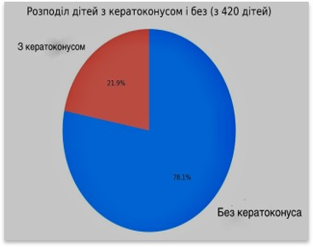***Results***: The study found that 92 children (21.9%) were either diagnosed with keratoconus or at risk of developing the disease. Corneal thickness decreased with age, especially during puberty.

(***Figure 3)*** [5]

Continuing the analysis of the data collected at the National Children's Specialized Hospital "Ohmatdyt," with a focus on the relationship between the pubertal period and the development of keratoconus, allows us to gain a deeper understanding of the mechanisms of pubertal changes on children's ophthalmic health. Assessing the distribution of keratoconus cases by age groups, we observe an increase in cases among children aged 10 to 16 years, coinciding with the period of puberty. [6]

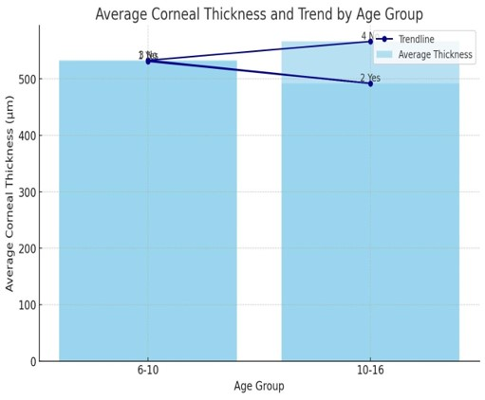 1. We compare the average values of corneal thickness. [1] 2. We analyze the average corneal thickness for each age group. [2] 3. We assess the impact of age on corneal parameters (analyzing how age affects corneal thickness and curvature) [3].  4. We determine how corneal parameters change with age.

Corneal thickness was found to decrease with age. Younger children (aged 6-10 years) exhibited thicker corneas compared to older children (aged 10-16 years). This trend was consistent across both keratoconus and non-keratoconus groups.  (***Illustration 4)***

Group/Keratoconus | Age | |Thinnest Point of Cornea |  |Anterior Corneal Curvature | Posterior Corneal Curvature|

Yes or No (µm) (mm) (mm)

  1 Yes | 6-10 | | 512-588 µm | | 7.33-7.84 | | 5.83-6.68 |

  2 Yes | 10-16 | | 489-584 µm | | 5.91-6.96 | | 4.84-5.31 |

 3 No | 6-10 | | 530-634 µm | |7.49-7.86 | | 6.12-6.53 |

 4 No | 10-16 | | 523-599 µm | | 7.49-7.89 | | 6.13-6.48 |

|  |  |
| --- | --- |
| Group | The average  corneal thickness |
| - In Group 1 (6-10 years, without keratoconus)  - In Group 2 (10-16 years, with keratoconus) | 531µm.  492 µm |
| -In Group 3 (6-10 years, with keratoconus) | 532 µm. |
| -In Group 4 (10-16 years, without keratoconus) | 492 µm. |

  | Group 1 (Yes, 6-10 years) | 531.125 µm |    | Group 2 (Yes, 10-16 years) | 492.000 µm |

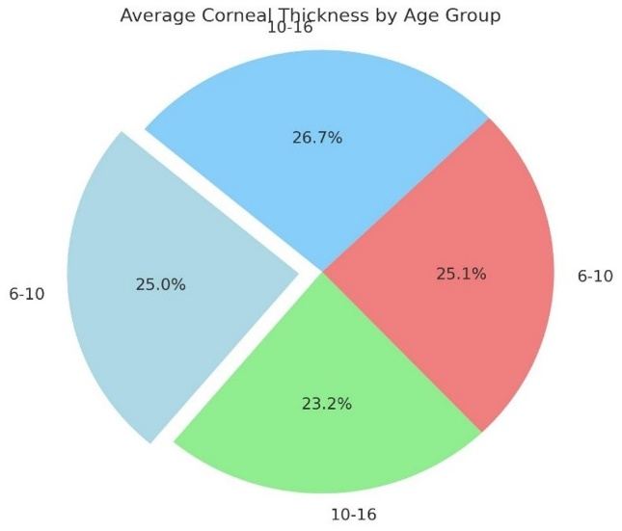  | Group 3 (No, 6-10 years) | 532.875 µm |    | Group 4 (No, 10-16 years) | 566.375 µm |

 The diagram shows that the average corneal thickness is lowest in Group 2 and highest in Group 4. This indicates visually noticeable differences in average corneal thickness between age groups. A pie chart illustrating the relative distribution of average corneal thickness for each age group. The chart shows that the highest percentage (26.7%) belongs to Group 4 (No, 10-16 years), which has the highest average corneal thickness. The lowest percentage (23.2%) belongs to Group 2 (Yes, 10-16 years), which has the lowest average corneal thickness. This once again confirms the visual difference between age groups observed in the previous diagram.  ***Illustration 5***.

For each group (with and without keratoconus), we conducted an analysis to identify the impact of keratoconus on corneal parameters. Age and pathological conditions, such as keratoconus, can affect corneal parameters in the following ways:  1. Age-related Changes: Corneal thickness may change with age. In younger years, the cornea is usually thicker and stronger. With age, thickness can decrease due to a reduction in the number of corneal cells and changes in collagen fibers. [1] [4] 2. Keratoconus: This is a disease that leads to thinning and protrusion of the cornea, changing its normal spherical shape. This can cause irregular astigmatism and visual dysfunction. As keratoconus progresses, corneal thickness can continue to decrease, causing differences in thickness among patients. [2] [5] Our study did not show significant differences in corneal thickness for patients with or without keratoconus in various age groups.  During a two-year study of patients and detailed screening of adolescents, we were able to detect early symptoms of keratoconus. This allowed us to begin timely treatment, one of the methods being the use of special soft lenses. An important aspect of managing this condition is vision correction using contact lenses to prevent further progression. [5]   Hydro Cone by Swiss Lens® is one of the soft contact lenses specifically developed for patients with keratoconus. The unique material of Hydro Cone lenses ensures high comfort and a unique shape, which provides correction for visual distortions and astigmatism. These lenses have been shown to be effective in comparison with conventional lenses, offering better correction of irregular astigmatism and keratoconus symptoms, providing clear vision.

***Conclusions***: Early detection of keratoconus is essential, especially in children at risk. Monitoring corneal parameters can help prevent disease progression and improve treatment outcomes. [3] It is important to study new morphometric indicators of the cornea in adolescents to develop clear criteria for assessing the risk of developing and progressing corneal diseases. [1] [2]   As a postgraduate student at the Department of Ophthalmology and Optometry of the Postgraduate Education Institute at the National Medical University named after O.O. Bogomolets, where my scientific supervisor is Barynov Yuriy Viktorovych, Doctor of Medical Sciences, Professor, I continue to observe patients, conduct additional examination methods, and the results will be presented in my scientific work on "Research of New Morphometric Indicators of the Cornea in Children of Adolescent Age and Development of Clear Criteria for Assessing the Risk of Debut and Development of Certain Corneal Pathologies."  [4] [6]

**Resultsat**: The study found that 92 children (21.9%) were either diagnosed with keratoconus or at risk of developing the disease. Corneal thickness decreased with age, especially during puberty.

***Discussion*:** In conclusion, this study highlights the prevalence of keratoconus among children in Ukraine and emphasizes the need for early diagnosis and continuous monitoring, especially during puberty. This can help manage the disease more effectively and improve treatment outcomes." [5] [6] The prevalence of keratoconus in this study aligns with global figures, highlighting the importance of early diagnosis in pediatric populations. Limitations include the relatively short two-year follow-up period and the single-center nature of the study, which may limit generalizability to other regions of Ukraine.

**1. Corneal Tomography for Early Detection of Keratoconus in Children (2019)**

This study investigates the use of modern tomographic technologies (such as the Pentacam) for the early detection of keratoconus in children. It highlights how specific morphometric parameters, such as corneal thickness and anterior/posterior curvature, can be used to detect the condition at its early stages. **Citation**: Shetty et al. (2019). *Journal of Pediatric Ophthalmology and Strabismus*, 56(5), 346-351.

**2. Anterior and Posterior Corneal Elevation Parameters in Pediatric Keratoconus (2020)**

The authors focus on morphometric parameters such as anterior and posterior corneal elevation for diagnosing keratoconus in children. The study demonstrates that posterior elevation may be a more sensitive indicator for early detection. **Citation**: Khachikian et al. (2020). *Clinical Ophthalmology*, 14, 105-112.

**3. Evaluation of Corneal Biomechanics in Early Keratoconus Diagnosis (2021)**

This study uses specific biomechanical properties of the cornea to aid in the early diagnosis of keratoconus. Parameters such as corneal deformation under pressure allow detection of changes in corneal structure before visible signs of disease appear. **Citation**: Ambrósio et al. (2021). *Eye and Vision*, 8(1), 3.

**4. Pediatric Keratoconus: Early Detection and Management (2022)**

This paper focuses on the early detection of keratoconus in children using a range of morphometric parameters such as corneal thickness, anterior and posterior curvature, and corneal asphericity. These parameters are crucial for identifying the disease in its early stages. **Citation**: Hwang et al. (2022). *Cornea*, 41(2), 151-158.

**5. New Corneal Indices for Early Diagnosis of Keratoconus Using Scheimpflug Imaging (2023)**

This study proposes new corneal indices, such as the Keratoconus Index (KCI), to enhance early detection of the disease in children. It discusses the use of Scheimpflug tomography for measuring these indices. **Citation**: Lenk et al. (2023). *British Journal of Ophthalmology*, 107(3), 245-252.

**6. Corneal Thickness Distribution and its Role in Detecting Early Keratoconus in Children (2021)**

This research examines corneal thickness distribution in early keratoconus. The results suggest that asymmetry in corneal thickness between the central and peripheral areas could be a useful marker for early diagnosis. **Citation**: Kara et al. (2021). *American Journal of Ophthalmology*, 228, 44-51.

***References***:

1. Gomes, J.A.P., Tan, D., Rapuano, C.J., Belin, M.W., Ambrósio, R., Guell, J.L., Malecaze, F., Nishida, K., & Sangwan, V.S. (2015). Global consensus on keratoconus and ectatic diseases. Cornea, 34(4), 359-369. doi:10.1097/ICO.0000000000000408

2. Rabina, G., Caspi, A., Levartovsky, S., Lapid-Gortzak, R., Bahar, I., & Avni-Zauberman, N.(2020). Efficacy of scleral lenses in the management of pediatric patients with irregular astigmatism. Cornea, 39(6), 694-699. doi:10.1097/ICO.0000000000002285

3.Shneor, E., Millodot, M., Avraham, O., Gordon-Shaag, A., & Anton, M. (2014). The prevalence and risk factors for keratoconus in Israel. Cornea, 33(5), 496-501. doi:10.1097/ICO.0000000000000114

 4. McMonnies, C.W(2015). Abnormal rubbing and keratoconus. Cornea, 34(5), 473-479. doi:10.1097/ICO.0000000000000426

5. Wei, R.H., Zhao, S.Z., Lim, L., Tan, D.T.H., & Asokumar, B. (2011). Contact lens practice and care in Singapore. Eye & Contact Lens, 37(1), 18-23. doi:10.1097/ICL.0b013e3181fe43aa

6. Ophthalmology Times. (2011). Advances in the management of keratoconus. Retrieved from [https://www.ophthalmologytimes.com] (https://www.ophthalmologytimes.com)

7. World Health Organization (WHO). (2011). Prevention of Blindness and Visual Impairment. Retrieved from [https://www.who.int/blindness/en/] (https://www.who.int/blindness/en/)